Setting Up an Oracle JET Application

This document provides a step-by-step set of instructions guiding you through the process of setting up an application based on [Oracle JavaScript Extension Toolkit (JET)](http://oraclejet.org/). JET empowers web and mobile developers by providing a modular toolkit based on modern JavaScript, CSS3, and HTML5 design and development principles.

Setting Up

In this exercise you learn how to set up an Oracle JET application via the ojet-cli tool.

1. On the command prompt in a terminal window, type the following:

node -v

If the terminal window shows that Node is not installed or at a lower version than 5, [go to the Node site](https://nodejs.org/en/) (<https://nodejs.org/en/>)  and install the Long Term Support (LTS) release of Node.

1. After completing the above step, install the Oracle JET Command Line ([ojet-cli](https://github.com/oracle/ojet-cli)) tool as follows:

npm -g install ojet-cli

**Note:** You may need to be in admin mode, such as via sudo -s on Mac OS X, to be able to call the above command.

Under the covers, the ojet-cli tool installs and uses popular JavaScript tools, such as Yeoman and Grunt, as can [be seen here](https://github.com/oracle/ojet-cli/blob/master/package.json). The -g argument in the previous step should have installed the ojet command globally, so that you should be able to run ojet anywhere, i.e., not in any specific folder or location since the ojet command should now be globally available. To try it out, run the following:

ojet help

The terminal window should now show all the commands available to be used with ojet. If not, you can manually configure the PATH of your system to include ojet-cli.

1. Once you have successfully run ojet help, use ojet to create a new Oracle JET application, as follows:

ojet create MyApp --template=navdrawer

'navdrawer', in the command line above, is one of the starter templates made available by Oracle JET, as outlined below:

* + [Nav Drawer Starter](http://www.oracle.com/webfolder/technetwork/jet/globalExamples-Starter-Drawer.html)
  + [Nav Bar Starter](http://www.oracle.com/webfolder/technetwork/jet/globalExamples-Starter-NavBar.html)pm
  + [Basic Starter](http://www.oracle.com/webfolder/technetwork/jet/globalExamples-Starter-Basic.html)

After the process completes, you should have an application structured as follows:

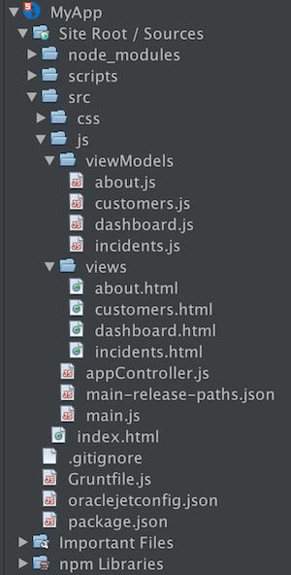

Open the application into an editor or IDE of your choice, such as NetBeans IDE, which displays the application as shown in the screenshot above.

1. Once the application is created, use the terminal window to navigate into the root folder, i.e., the top folder, which is named MyApp, and build and serve the application, as follows:

ojet serve

After the build completes, the browser opens and displays the application:

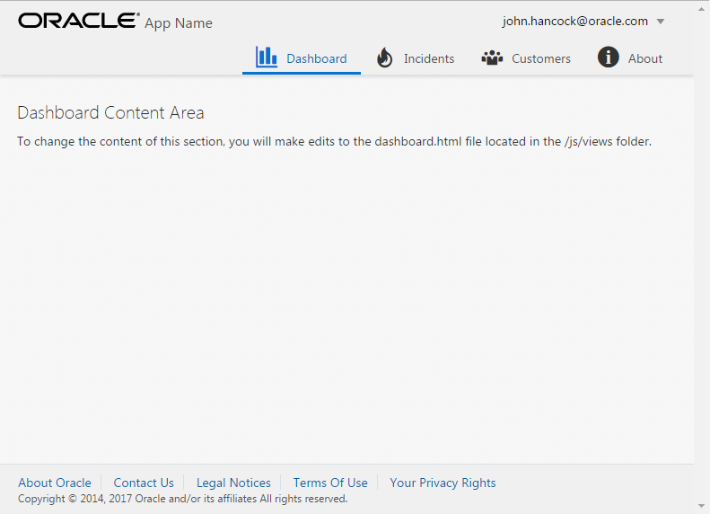

Congratulations, you have successfully set up an Oracle JET application. Repeat the steps above whenever you need to set up a new Oracle JET application.